System Requirement Specification(SRS)
Project : Recruitment Solution Agency( RSA)
Team: Shining stars

Version 2.0

NAME | CONTACT NO | EMAIL
Uma Bharti Rana | 0416987781 | atmcstars@gmail.com
Poonam Sen | 0430717000 | atmcstars@gmail.com
Anmoldeep Singh Gill | 0468315056 | atmcstars@gmail.com
Amy Zheng | 0424676155 | atmcsatrs@gmail.com
Mohammed Nasser Alzuabi | 0413242552 | atmcstars@gmail.com
Bilawal Ansari | 0416793134 | atmcstars@gmail.com

Table of Contents
1. Introduction to SRS: 5
1.1 Purpose: 5
1.2 Scope: 5
2. Overview of the proposed system: 6
2.1 Aim: 6
2.2 Scope: 6
2.3 Brief information about system: 6
2.4 User characteristics 7
Admin 7
Employers 7
Job seekers 7
2.5 Some definitions: 8
2.6 Abbreviations 8
3. Client and Team information 8
4. System Functions: 9
5. System Feasibility 11
6. Use Cases Scenario: 12
6.1 Job seeker Level: 12
UC-1: Manage Personal Profile 12
Use Case Diagram : 12
UC-2: Upload CV 13
Use Case Diagram : 13
UC-3: Job application status 14
Use Case Diagram : 14
6.2 Employer Level 15
UC-4: Post Jobs 15
Use Case Diagram : 15
UC-5: Receive jobseeker CV 16
Use Case Diagram : 16
UC-6: View Job seeker profile 17
Use Case Diagram : 17
UC-7: Hire Jobseeker 18
Use Case Diagram : 18
6.3 Administrator Level: 19
UC-8: Handle Users 19
Use Case Diagram : 19
UC-9: Announcements 20
Use Case Diagram : 20
7. Requirements: 21
7.1 Functional Requirements: 21
7.2 Non-functional Requirements 23
7.3 Hardware Requirements 24
Client-side 24
Server-side 24
7.4 Software Requirements 24
Client-side 24
Server-side 24
7.5 Database Requirements: 25
8. Entities relationship diagram 25
8.1 Relational data structure 26
8.2 Database Schema 26
9. Appendix 31
9.1 Context Diagram 31
9.2 DFD level 0 32
9.3 DFD level 1 (Job Seeker) 33
9.4 DFD Level 1 (Employer) 33
9.5 DFD Level 1 (Admin) 34
10. Use Case Diagram: 34
11. Limitations and Constraints 35
12. References 36

Introduction to SRS:

SRS stands for Software Requirement Specifications. In this document we will describe about the requirements of the whole system which we are going to design for our client. This will include information about scopes, constrains, limitations, functional and non functional requirements, apart from that this document will focus on the system that how it will interact with other requirements. This will help us to clear all the issues between client and developers.
As this document is completely based on the requirements, this is really important that our designers and client should be very clear about the final product, any misunderstandings or issues can be easily resolved at this stage with the help of SRS.

1.1 Purpose:

The main purpose of this document is:
- Describe various components of the system
- Information about what system is supposed to achieve and how
- Details of the functional and non functional requirements
- Quick view of entities and their relationships
- Information about different level of DFD’s
- How system interact with user and within entities
- Outline the modules and parameters in structural decomposition diagrams

1.2 Scope:
SRS is the document which we make requirements more clear and defined. SRS will give exact information to the designers and developers about the system required by the client. It will be more technical rather than verbal information.
SRS plays very important role in the development of our system. It defines all the requirements of all the three different levels of our system -
- Admin
- Employer
- Job Seeker

Overview of the proposed system:

2.1 Aim:
The main aim is to develop a fully functional system for RSA, where job seeker can apply for jobs, and employers can post their jobs and admin can make these things happen by recruiting people. It will include different process like database creation, website creation, documentation, architectural design, testing etc.
Our team will get all the functional and non-functional requirements from the client and will get feedback after completing each stage of the system, in order to achieve a fully functional system.

2.2 Scope:
The scope is to fulfill the requirements and needs outlined by the client. The skills and abilities of the project team is qualified to develop the system for the client, but may not have enough experience in design the system for recruitment agency. It needs project team to do some research to gain the knowledge of increase the efficiency of recruitment system and more communication with client.

2.3 Brief information about system:
Our system will be used by the RSA group, where they can recruit new people and associate with new employers or companies. New candidates or employees or job seekers can register with agency via our website registration form and fill all details and create their user ID as email and select password. Later on they can sign in anytime and search or apply jobs which are listing in job listing page and uploaded by companies which are already register in agency. Employees can update their profile such as their resumes, addresses or other details as well. Agency sends our registered employees to the requested companies according to employee’s skills and availability. Employers can post jobs on the job listing page, they can send requirements to RSA and agency will manage the interview date for both employers and jobseekers.

2.4 User characteristics

Admin
- Add/Delete categories
- Add/Delete jobs
- Add/Delete new jobs every month
- Update status
- Responses to User enquires and feedbacks
- Add or remove (suspend) employers/job seekers
- Manage user levels

Employers
- Register online
- Login with user name and password
- Upload jobs
- Can search or check job seeker profile

Job seekers
- Browse the website
- Register online
- Login with user name and password.
- Upload CV
- Job search
- Apply jobs
- Can check their application status
- Feedbacks and enquiries
- Can view and update their personal information
- Download Timesheets

2.5 Some definitions:

- Functional requirements: These are the requirements which a system must have in it. This includes functions of the system software and its components. For a fully functional system these requirements must be filled.
- Non Functional requirements: Non-functional requirements are those which are not connected with in the system, but these are also important to have a really reliable system.
- System context diagram: This tells us how an actor outside the system will interact inside the system, or how system responds to the outsiders.

2.6 Abbreviations

RSA | Recruitment Solution agency
SRS | System Requirement Specifications
PM | Project Manager
SCD | System Context Diagram
DFD | Data Flow Diagram
ERD | Entity Relationship Diagram
UC | Use Case
FR | Functional Requirements
NFR | Non Functional Requirements

Client and Team information
Company name: RSA (Recruitment Solution Agency)
Client Name: Anna Damos
Contact Info: 0415559142
Address: 16 Coulstock Street
Epping Vic 3076
Company Logo: 

Team Name: Shining star
Team logo:


Team Members:
Full Name | Students Number | Contact Number
Uma Bharti Rana | 30097479 | 0416987781
Poonam Sen | 30099177 | 0430717000
Anmoldeep Singh Gill | 30102252 | 0468315056
Xiaoping Zheng (Amy) | 30099748 | 0424676155
Mohammed Nasser Alzuabi | 30101848 | 0413242552
Bilawal Ansari | 30091848 | 0416793134

Contact info: www.shiningstars6.weebly.com
atmcstars@gmail.com

System Functions:
RSA will incorporate and consist of many specific functions with the primary aim of increasing the efficiency of recruitment process and reducing the amount of maintenance required. It will reduce the amount of labor involved in administration area. These functions will be designed with interfaces that are as user friendly as possible to allow a broad range of end users, for all three levels of users to use the system (admin level, employer level, job seeker).
The main functions of the system are as follows:
- Register Online
Job seeker and employer can register online, and after registration they can login with their user name and password.
- View Profile
Registered job seeker and employers are able to view their profile and all the status and notification of events and schedule.
- Edit /Update Profile
They will be able to edit their profile, for example change address, phone numbers etc.
- Post Resume
Every registered job seeker will be able to post their resume on the system.
- Job Posting
Posting and managing jobs, employers can post their job requirements from job posting module with complete details.
- Search Jobs
Registered jobseekers can type the key word of the job they looking for into search box, and then find the relevant job.
- Jobs Alerts
Job seeker can subscribe to jobs alerts for desired categories. After which the jobseekers will received emails whenever new jobs are posted in the categories they subscribe from this job alert which enables them send their application for the same.
- Delete Member
If a member decided to leave, the administrator will delete his/her current status but the profile will be kept in the system.

System Feasibility
- Economic
From the economic point of view, the new proposed system is more efficient for entering and retrieves data. The processing of system is also high and online access is also compatible. It will reduce the cost for RSA, such as labor cost, maintenance cost.
- Integrity
The new proposed system define the security attributes of the system like restricting access to features or data to mangers and protecting the privacy of data entered into the system.
- Usability
The system will provide more function for jobseekers and employers, they can easily manage their account at any time or anywhere.
- Reliability
The System will be able to recover from any serious data loss, maintenance issues and security related issues.
- Technical
The technical feasibility of the project is under the control of the project team and client. All factors including project team skills and abilities and the capacity and capability of the hosting infrastructure will be taken into consideration when designing the solution to ensure that the project is technically feasible.

Use Cases Scenario:

6.1 Job seeker Level:

UC-1: Manage Personal Profile

Name | UC-1: Manage Profile
Summary | Job seeker can change information into their profiles and Admin will allow them to make changes, which include profile edit, delete, and update.
Rationale | If there is unnecessary date and fake profiles that are running on the site then Admin will have rights to remove or delete the profile.
Actor | All Users
Pre-Condition | Profile and record must exist
Basic course of Event | - User opens the desired module of the system.  - The system displays GUI of different pages.  - User will input the necessary data into the fields.  - System will update the record as per requirements.
Post- Condition | User receives the notification that profile has been approved or profile has been updated.

Use Case Diagram :

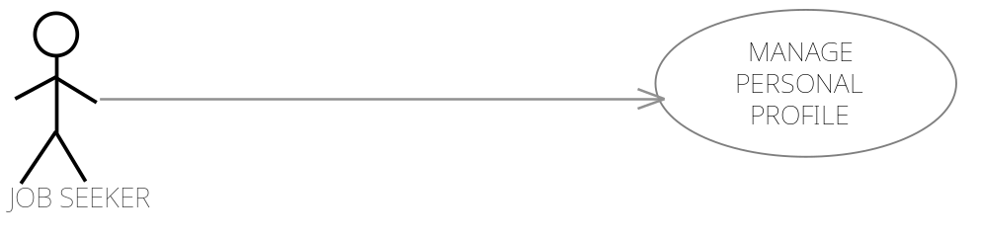

UC-2: Upload CV

Name | UC-2: Upload CV
Summary | Job seeker can post his/her CV on job portal, so that recruiter can contact them
Rationale | If there are new promotions or jobs required by RSA team then Admin will make announcements and publish it on system.
Actor | Job seeker
Pre-Condition | New Jobs and other features should be displayed.
Basic course of Event | - Job seeker search for a specific job category.  - The system displays GUI for the new jobs and features.  - Job seeker clicks on the new jobs option and upload his/her CV there.  - System will show all the CV on the admin and job seeker end.
Post- Condition | CV successfully uploaded.

Use Case Diagram :



UC-3: Job application status

Name | UC-3: Job application status
Summary | Job seeker can post their CV, later they can check its status either their application is accepted or rejected.
Rationale | If their application is accepted and rejected, then they must know about the status, so that they can further proceed.
Actor | Job seeker
Pre-Condition | CV must be posted by job seeker.
Basic course of Event | - The job seeker login to system and check status of his application  - The system displays GUI for the job application page.  - Job seeker clicks on the page and check its status.  - System will show all the results regarding their post on the jobs.
Post- Condition | Result successfully shown to the job seeker

Use Case Diagram :

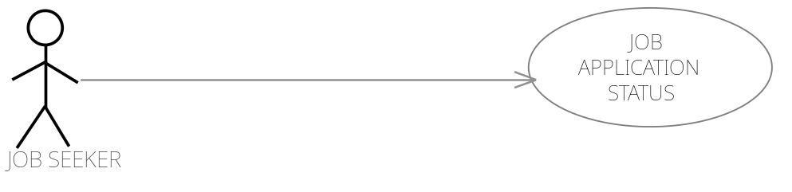

6.2 Employer Level

UC-4: Post Jobs

Name | UC-4: Post Jobs
Summary | Employer can post the job
Rationale | Employer wants to find the right employees for specific job.
Actor | Employer
Pre-Condition | Employer must have a task and reasonable price for that task
Basic course of Event | - Employer access the required page to post the job.  - System will show the appropriate GUI for posting the project.  - Employer will fill all the required fields and describe the category and type of a project.  - System will post the job.
Post- Condition | Anyone can see the posted job and apply for it after registration.

Use Case Diagram :



UC-5: Receive jobseeker CV

Name | UC-5: Receive jobseeker CV
Summary | Employer can receive jobseekers CV.
Rationale | When a job will be posted from Employer then RSA contact with Employer for a particular job and give them information about specific job seekers.
Actor | Admin/ Employer
Pre-Condition | There must be a project on which Employer and Admin can talk with each other.
Basic course of Event | - Employer can receive CV of job seeker from admin or from job seeker profile.  - Admin can negotiate with Employer.  - System will provide support to Employer to hire or decline the job application.
Post- Condition | Admin will get notification that either employer has been declined or hired job seeker.

Use Case Diagram :



UC-6: View Job seeker profile
Name | UC-6: View Job seeker profile
Summary | Employer can search the job seeker by name and can view the whole portfolio of job seeker.
Rationale | If an employer has a job then he can search the job seeker and see entire profile of all employees or jobseekers.
Actor | Employer
Pre-Condition | Employer must be exist in a list
Basic course of Event | - The user indicates that the system is to perform a search function.  - System responds by the requesting the search term and shows the results.  - System will show the entire job seeker in a relevant field in which employer wants.
Post- Condition | Employer can see whole information about the job seeker.

Use Case Diagram :

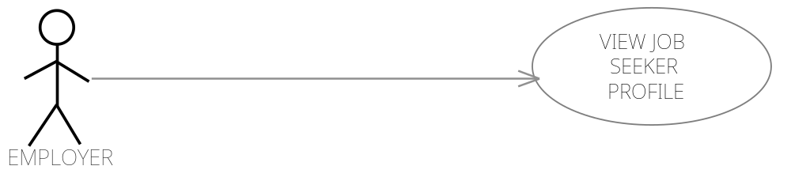

UC-7: Hire Jobseeker

Name | UC-7: Hire Job seeker
Summary | Employer can hire the employee for a specific job required
Rationale | Employer has a job and wants to search the employee for the project if found , employer will hire the job seeker for a particular project.
Actor | Employer
Pre-Condition | Employer should have a project.
Basic course of Event | - The user indicates that the system is to perform a search function.  - System responds by the requesting the search term and shows the results  - System will show the entire list of job seeker.  - Employer will negotiate with admin and hire job seeker.  - System will send the hired notification to the Employer and Administrator and as well as job seeker.
Post- Condition | Job seeker will receive the notification that he or she has been hired.

Use Case Diagram :



6.3 Administrator Level:

UC-8: Handle Users

Name | UC-8: Handle Users
Summary | Admin can view all the users proceedings.
Rationale | If admin wants to job seeker and employer previous history about jobs and hiring then Admin can see all previous history.
Actor | Admin
Pre-Condition | Previous history must be exist in database
Basic course of Event | - The user will access the record.  - System allows user to see previous history.  - User will generate the report.  - System will show all the existing record to the users.
Post- Condition | User will get the previous records.

Use Case Diagram :

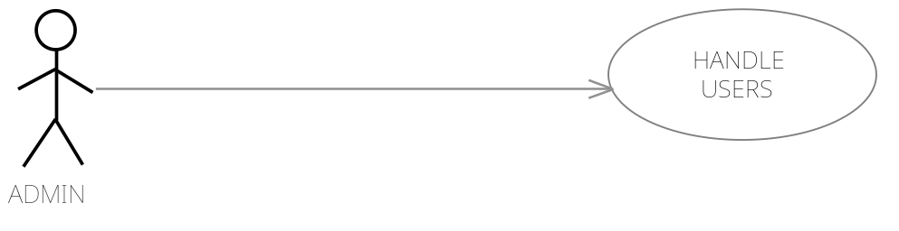

UC-9: Announcements

Name | UC-9: Announcements
Summary | Admin can make announcements for the new jobs and publish new features.
Rationale | If there are new jobs and new features will be add on to RSA system then Admin will make announcements and publish them for the users.
Actor | Admin
Pre-Condition | New jobs and promotions should be created for the users interest.
Basic course of Event | - The user opens the administrator module of the system.  - The system displays GUI for the promotions and announcement.  - Admin will update the new services and events for the users.  - System will show all the events and announcements on a site for the users.
Post- Condition | Administrator will receive the confirmation message or email, that new services and events has been posted successfully.

Use Case Diagram :

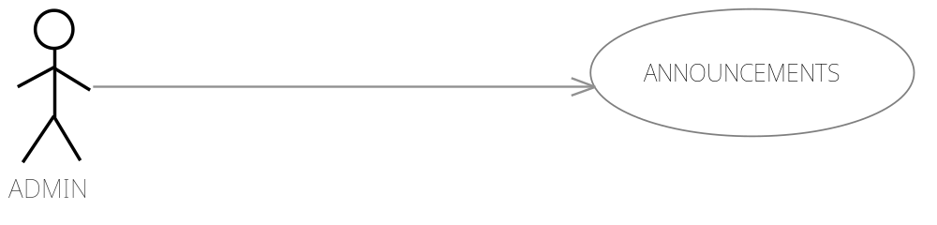

Requirements:
The requirements will be divided in functional and non-functional requirements.

7.1 Functional Requirements:
These requirements are the core requirements of the system, which we are developing.

Functional Requirement Id | Requirement Name | Details of requirement | Priority
FR001 | Authentication | The system will provide functionality to all the users once they log onto the system with their user name and password. On the basis of their levels they will be directed to different pages or section | Essential
FR002 | Login declined | If user enters wrong username and password it will show the error message. | Essential
FR003 | Admin changes | Once admin log in to the system, they can easily see everything about employees and employers and they can make changes as required | Essential
FR004 | Job listing | Employers can post jobs, and specific details | Essential
FR005 | Registration form | A job seeker can register online to apply for the job or as employee | Essential
FR005 | Addition of employee to the list | Admin will have the ability to add job seeker to the employee list | Essential
FR006 | Reset password | Due to privacy concerns any registered user in the system can change their login password | Essential
FR007 | Upload CV | Job seeker can upload their CV including cover letter to apply for job | Essential
FR008 | Download CV | Admin can download CV of the applicant from the system | Essential
FR009 | Edit CV | Job seeker can upload new CV to the profile. Older one can replace by new one. | Essential
FR010 | Update Job Details | Admin can make changes to the job listed already | Essential
FR011 | Change bank details | Employee can change their bank details just by sending the emails to the agency website. | Essential
FR012 | Change address | All users can change their address as required. | Essential
FR013 | Apply for job | Job seeker can apply for job after registration. | Essential
FR014 | Suspend a user | Admin can suspend a user from system as required. | Essential
FR015 | Reference no for application | System will generate a reference no for job seeker application. | Essential
FR016 | Categories jobs | Employer can select a category to post a job. | Essential
FR017 | Feedback form | Job seeker can send feedback to admin by contact us page. | Essential
FR018 | Download time sheets | Job seeker can download the time sheet. | Essential
FR019 | Change employee/job seeker status | Admin can change status of job seeker like full time, part time or casual. | Essential
FR020 | New window | Each page will open in a new window | Essential
FR021 | Search Jobs | Job seeker can search for job by typing key words. | Essential
FR022 | Email a friend | Job seeker can email any job to his friend. | Optional
FR023 | Email confirmation of registration | Job seeker will get an email after registration is completed. | Essential
FR024 | Submit registration form | After filling registration form job seeker can submit the application | Essential
FR025 | Cancel Registration form | If job seeker does not want to submit the form they can cancel it | Essential
FR026 | Job Alerts | Job seeker can receive job alerts by email about specific job category | Essential
FR027 | Job Alerts | Employers can receive job alerts by email after applying jobs by job seeker. | Optional

7.2 Non-functional Requirements
Non-functional requirements are defined as non-core requirements of the system.
Non-Functional Requirement ID | Non-Functional Requirement Title | Detail of requirement | Priority
NFR001 | Usability | Due to the nature of the users, the system needs to be as simply as information technology system can be. | Essential
NFR002 | Aesthetics | The look of the site should be simple and use highly contrasting colors for text. The site should be more professional by looks. | Essential
NFR003 | Load time | Band width has to be as good as possible as there is large no of application. | Essential
NFR004 | Security | The system should be fully secured to keep data safe. | Essential
NFR005 | Privacy | The privacy of all the users of the site should be paramount. And no data should be shared with any third party. | Essential
NFR006 | Ethics | The system should meet all the ethical requirements , it should be non-partial and equal for all | Essential

7.3 Hardware Requirements

Client-side
The following requirements are the recommended minimum requirements for client users of the system. Satisfactory performance cannot be guaranteed if these specifications are not met:
CPU: Pentium II/Celeron (or equivalent)
RAM: 128MB
Display/Graphics card: 24-bit colour display, operating at least 800x600.
The user also is required to have a Mouse (or other pointing device), a keyboard and an Internet Connection.

Server-side
The following requirements are the recommended minimum requirements for the server component of the system. Satisfactory performance cannot be guaranteed if these specifications are not met.

7.4 Software Requirements

Client-side
- Any Web Browser capable of supporting common web standards, e.g. CSS. This includes, but is not limited to: Mozilla Firefox, Microsoft Internet Explorer, Safari, Netscape and Opera.

Server-side
As the Server environment is already determined the software requirements listed are for versions of programs already being used by the hosting environment.
- PHP v4.3.1 is needed to process all PHP script for the system.
- MySQL is needed to store all database.
- Firewall To protect the application from illegal activities.

7.5 Database Requirements:
The main requirement of the database is to have all the entities and a place to store data. These can be further will be explained by the ER diagrams and data schema etc.
The database will give us the idea how system will store the information provided and how to process that further with the provide information.

Entities relationship diagram

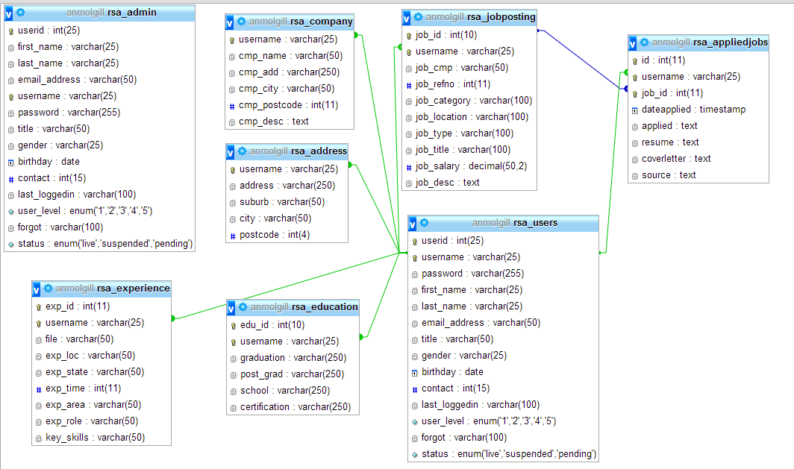

8.1 Relational data structure

rsa_users (userid, username, password, first_name, last_name, email_address, title, gender, birthday, contact, user_level, Status)
rsa_address (username, address, suburb, city, postcode)
rsa_admin (userid, first_name, last_name, email_address, username, password, title, gender, birthday, contact, last_loggedin, user_level, forgot, status)
rsa_jobposting (job_Id, username, job_cmp, job_refno, job_category, job_location, job_type, job_title, job_salary, job_desc)
rsa_company (username, cmp_name, cmp_add, cmp_city, cmp_postcode, cmp_desc)
rsa_education (edu_id, username, graduation, post_grad, school, certification)
rsa_appliedjob (Id, username, job_id, dateapplied, applied, resume, coverletter, source)
rsa_experience (exp_id, username, file, exp_loc, exp_state, exp_time, exp_area, exp_role, key_skills)

8.2 Database Schema

TABLE NAME | FIELD | TYPE | DESCRIPTION
RSA_USERS | userid | INT(25) | Primary key, Auto increment
 | username | VARCHAR(25)
 | password | VARCHAR(25)
 | first_name | VARCHAR(25)
 | last_name | VARCHAR(25)
 | birthday | DATE
 | contact | INT(15)
 | email_address | VARCHAR(50)
 | title | VARCHAR(50)
 | gender | VARCHAR(20)
 | last_loggedin | VARCHAR(100)
 | status | enum
RSA_ADDRESS | username | VARCHAR(25) | Foreign Key reference to rsa_user. username
 | address | VARCHAR(25)
 | suburb | VARCHAR(50)
 | city | VARCHAR(50)
 | postcode | INT(4)
RSA_ADMIN | userid | INT(25) | Primary key, Auto Increment
 | first_name | VARCHAR(25)
 | last_name | VARCHAR(25)
 | email_address | VARCHAR(50)
 | username | VARCHAR(25) | Foreign Key reference to rsa_user. username
 | password | VARCHAR(25)
 | title | VARCHAR(25)
 | gender | VARCHAR(25)
 | birthday | DATE
 | contact | INT(15)
 | last_loggedin | VARCHAR(100)
 | user_level | enum
 | forgot | VARCHAR(100)
 | status | enum
RSA_COMPANY | username | VARCHAR(25) | Foreign Key reference to rsa_user. username
 | cmp_name | VARCHAR(50)
 | cmp_add | VARCHAR(50)
 | cmp_city | VARCHAR(50)
 | cmp_postcode | INT(4)
 | cmp_desc | TEXT
RSA_EDUCATION | edu_id | INT (10) | Primary Key, Auto Increment
 | username | VARCHAR(50) | Foreign Key reference to rsa_user. username
 | graduation | VARCHAR(50)
 | post_grad | VARCHAR(50)
 | school | VARCHAR(50)
 | certification | VARCHAR(50)
 | job_cat | VARCHAR(50)
RSA_JOBPOSTING | job_id | INT(10) | Primary Key, Auto Increment
 | username | VARCHAR(50) | Foreign Key reference to rsa_user. username
 | Job_cmp | VARCHAR(50)
 | Job_refno | INT(11)
 | Job_category | VARCHAR(100)
 | Job_location | VARCHAR(100)
 | Job_type | VARCHAR(100)
 | Job_title | VARCHAR(100)
 | Job_salary | DECIMAL(50,2)
 | Job_desc | TEXT
RSA_APPLIEDJOB | Id | INT(11) | Primary key, Auto Increment
 | username | VARCHAR(25) | Foreign Key reference to rsa_user. username
 | Job_Id | INT(11)
 | dateapplied | TIMESTAMP
 | applied | TEXT
 | resume | TEXT
 | coverletter | TEXT
 | source | TEXT
RSA_EXPERIENCE | exp_id | INT(11) | Primary Key, Auto Increment
 | username | VARCHAR(50) | Foreign Key reference to rsa_user. username
 | file | VARCHAR(25)
 | exp_loc | VARCHAR(25)
 | exp_state | VARCHAR(25)
 | exp_time | VARCHAR(25)
 | exp_area | VARCHAR(25)
 | exp_role | VARCHAR(25)
 | key_skills | VARCHAR(25)

Appendix

9.1 Context Diagram
This is the system context diagram, showing three different levels as well as some of the main functions.
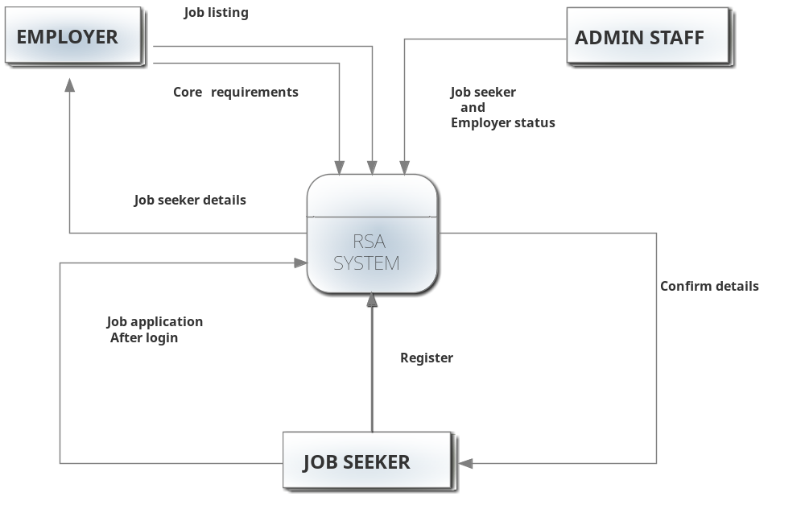

9.2 DFD level 0
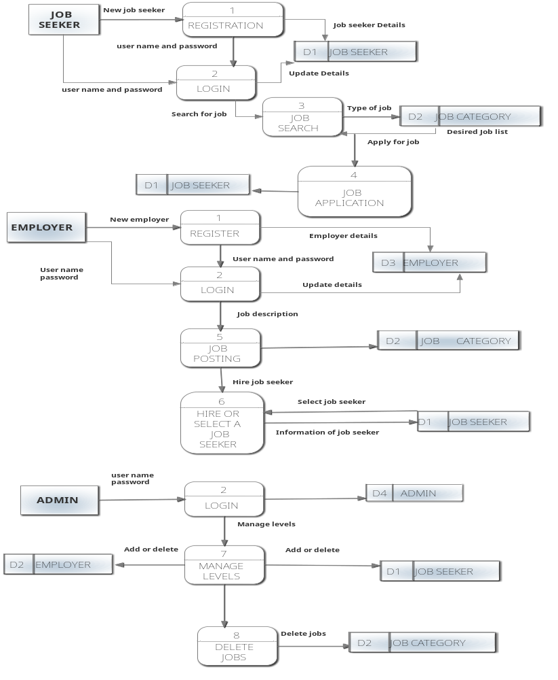

9.3 DFD level 1 (Job Seeker)

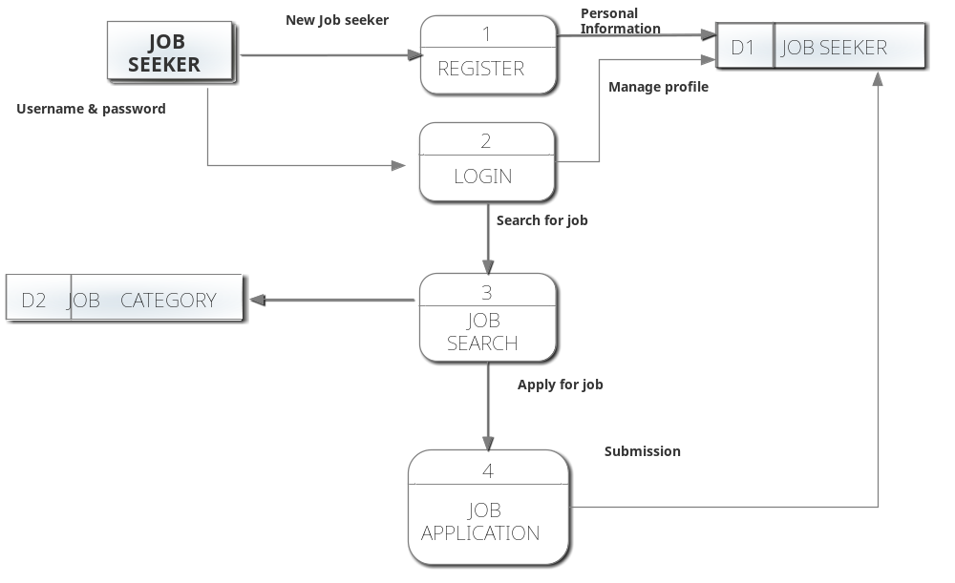

9.4 DFD Level 1 (Employer)

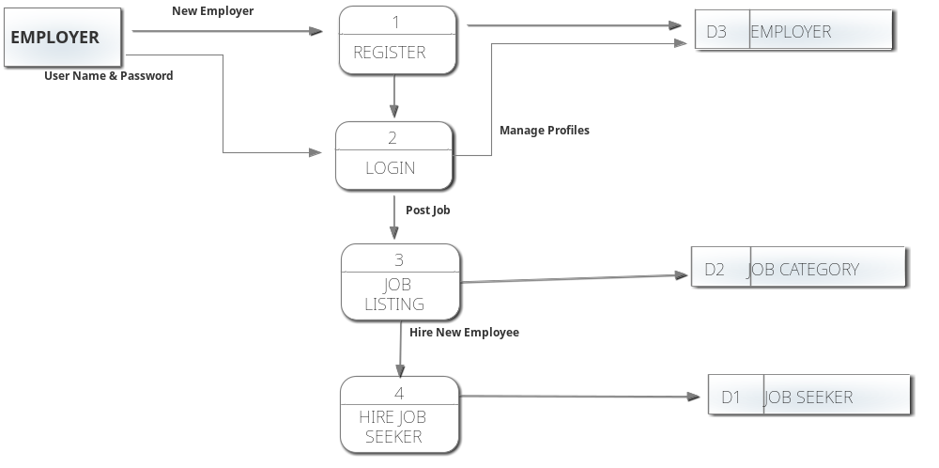

9.5 DFD Level 1 (Admin)
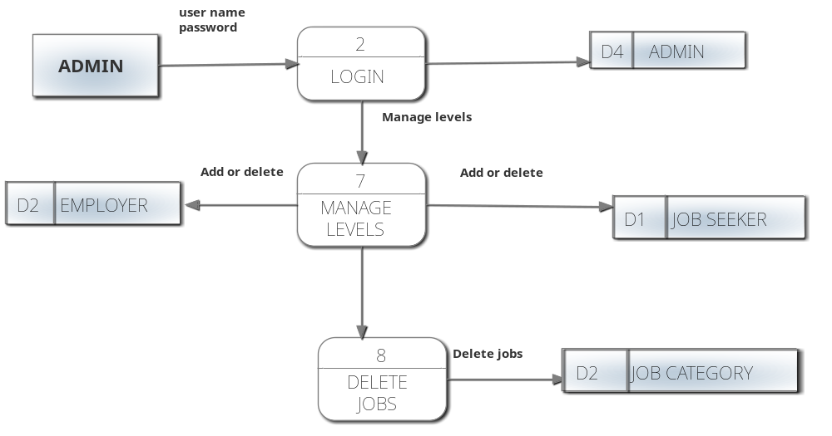

Use Case Diagram:
Use case diagram for whole system -
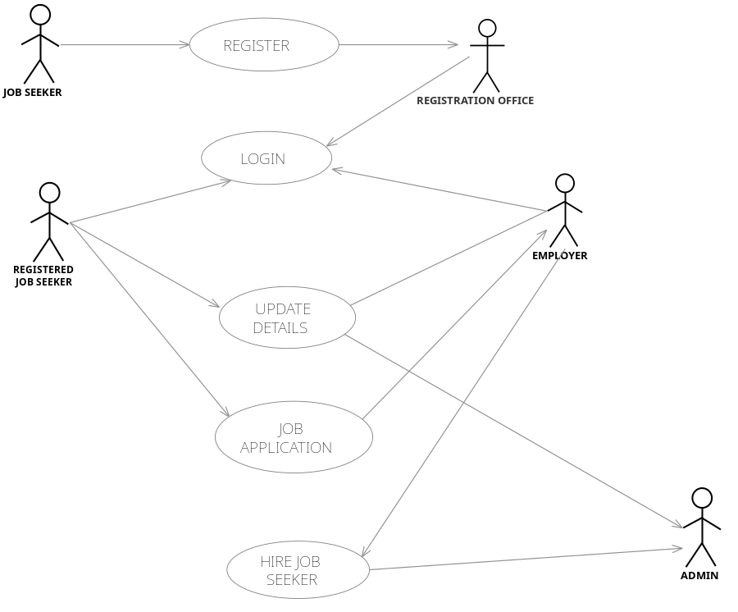

Limitations and Constraints
Our proposed system is developed for the fulfillment of all client requirements. But as the time constraints this is limits to some functional area. As it is developed by less experienced team there is some functions can’t be fulfilled. It will explain some more limitations and constraints functioned by system such as:
- The area is limited to the Melbourne and Geelong areas, It won’t cover other areas of Australia or worldwide.
- The Category of Job apply is also limited to 6 to 7 fields such as hospitality, IT, accounting etc.
- For apply any job or upload resume seeker must register in the company.
- Employer can’t post jobs and can see the seeker profile without registration.
- There is no contract between employers or employees with the company. They are free to add or remove their profile.
- For removing profile they have to send request to the admin, they can’t do by themselves.
- System can’t check the availability of the job seeker, admin or employers should do this manually.
- System can’t generate the pay slips and invoices automatically for the seeker.

References
John W. Satzinger, Robert B. Jackson, Stephen D. Burd (2004). System Analysis and Design in a Changing World (3rd ed.), Thomson Cource Technology, Boston, Massachusetts, USA.
Ludwig Consulting (2008). Templates and Guidance. Retrieved June 6, 2008, from http://www.jiludwig.com/Template_Guidance.html
Oregon Government (2008). Requirements Specification Template. Retrieved June 6, 2008, from http://www.oregon.gov/DHS/admin/pmo/data/executing_templates/requirements_template_lite.doc
Schwalbe, K. (2006). Information technology project management, (4th Ed.). Cambridge, MA: Course Technology.
Stephen Cooper (2008). Software Requirements Specification. Retrieved June 6, 2008, from http://www.sju.edu/~scooper/spring01se/SoftwareRequirementsSpecification.htm
Unknown Author (2008). Unknown Title. Retrieved February 14, 2008 – Not accessible June 6, 2008 from http://www.techwr-l.com/techwhirl/magazine/writing/softwarerequirementspecs.html

